POSITAL Rotary Encoder - How to
- Connect all rotary encoder (data and power)
- Server needs to be set in the correct IP range (take the IP range form the rotary encoder)
- Copy the folder d3driver_rotary_encoder onto your desktop
- Open a cmd window for every rotary encoder you want to use (therefor type cmd.exe)
- Type “cd desktop” (to navigate to your desktop)
- Type “cd d3driver” (to navigate to your folder)
- Type “d3driver.exe” (to run the exe)
- Now you should see the following message:

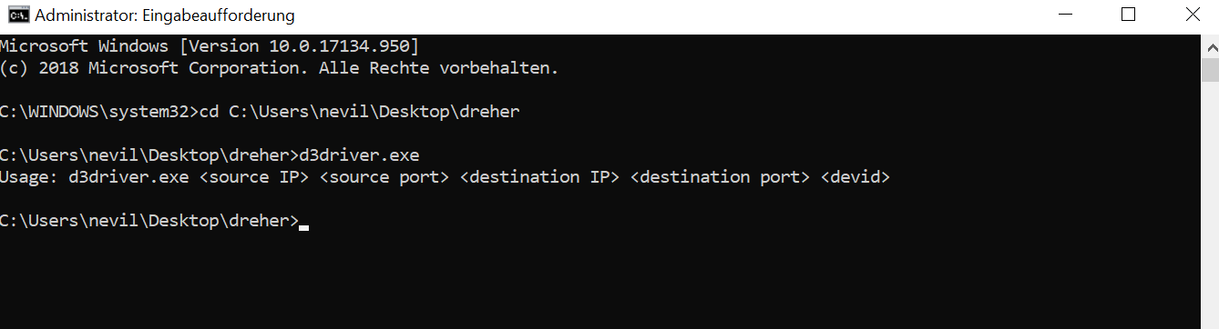

- To start the connected rotary encoder you need to assign the
  - source IP (the rotary encoder)
  - source Port (as shown on the rotary encoder)
  - destination IP (the server)
  - destination Port (you can set it as you wish, but keep it in mind)
  - driver ID (just set a number e.g. 1)
- Your command will look like e.g. this:
  - d3driver.exe 10.10.10.20 6000 10.10.10.47 6000 1
- Hit enter and keep the window open(!) and start d3
- First step in d3 is to create the object you wanna track or move (e.g. surface 1)
- Now you can create a position receiver
- In there you create a new driver
- Now you get a list of a ton of possible drivers. In our case we select the navigator driver
- In the window of the navigator driver you only have to set your port (e.g. 6000). Keep everything else as it is
- Now you create a axes (so d3 knows where and how to map the incoming data on the axis)
- In this axes window you need to engage
- Set the before selected ID (from your cmd)
- Select an object
- Type in the property (e.g. to control the surface 1 on the x axis you select surface 1 as the object and type in the property “offset.x”
  - see also: https://help.disguise.one/en/Content/Configuring/Expressions/Expressions.htm
- Last step is to engage the position receiver and have fun

Info: you can adjust/map/warp all incoming data in the axis window
Info:

